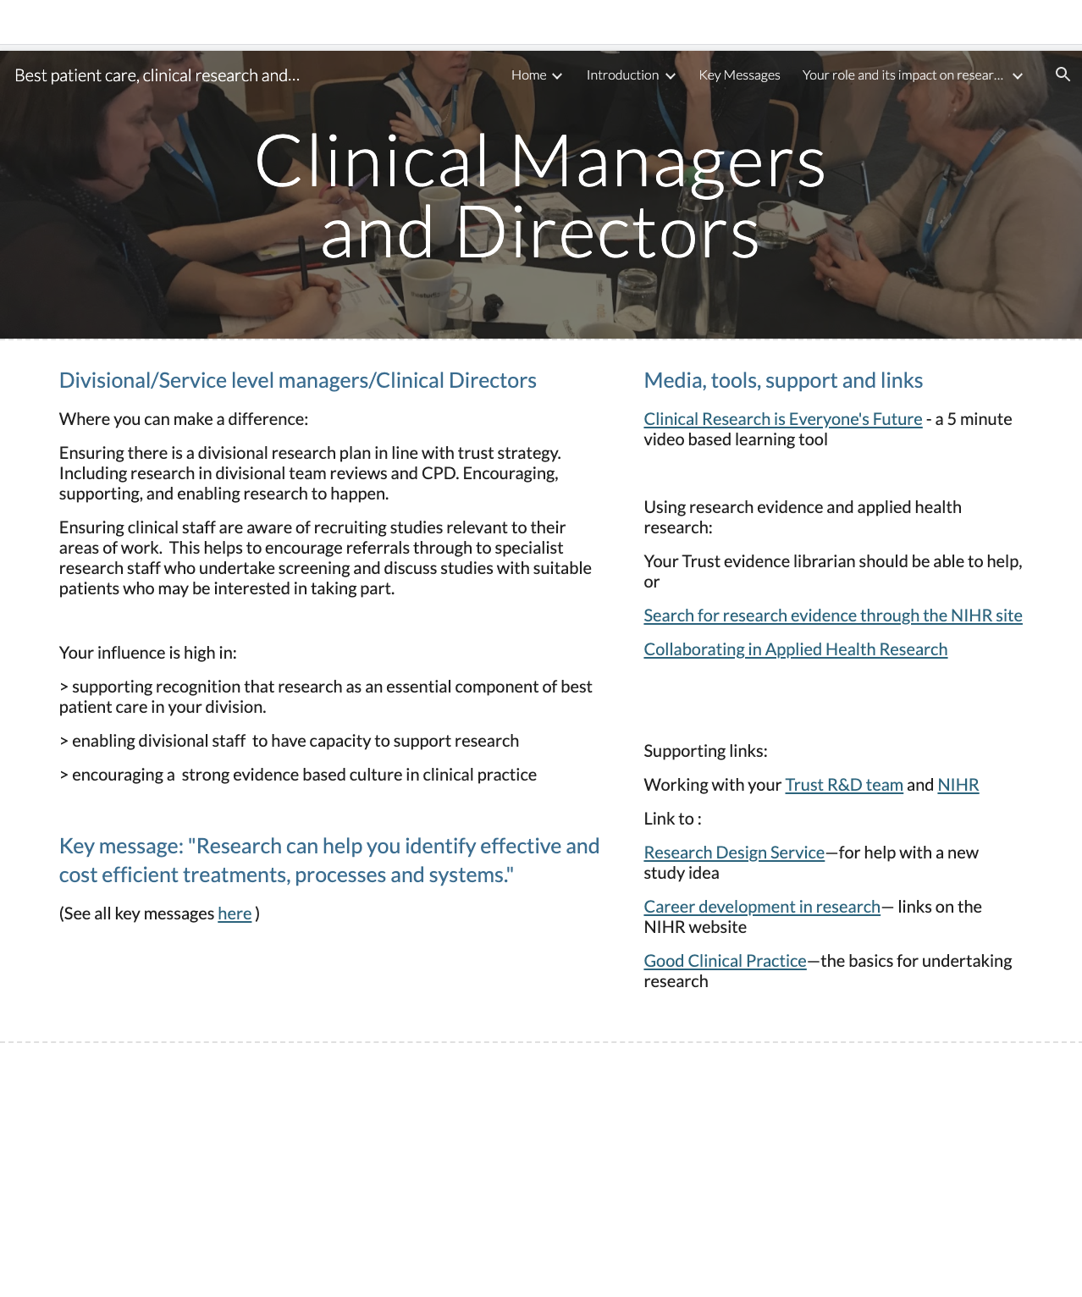
Page ID:
- Clinical Managers and Directors

Text content:
- Text, key message and key message link required - (left hand in above)
- Media, tools, support and links - supporting links re Trust R&D team can be localised and any other local resources added

Visual (non text) content and general layout:
- Keep what is in each column above associated in your local layout but do not conflate. Additional local pictures/visuals can be added.

Navigation:
- Back navigation is important

Text for copying:

Title: Divisional/Service level managers/Clinical Directors

Where you can make a difference:

Ensuring there is a divisional research plan in line with trust strategy. Including research in divisional team reviews and CPD. Encouraging, supporting, and enabling research to happen.

Ensuring clinical staff are aware of recruiting studies relevant to their areas of work. This helps to encourage referrals through to specialist research staff who undertake screening and discuss studies with suitable patients who may be interested in taking part.

Your influence is high in:

> supporting recognition that research is an essential component of best patient care in your division.

> enabling divisional staff to have capacity to support research

> encouraging a strong evidence based culture in clinical practice

Key message: "Research can help you identify effective and cost efficient treatments, processes and systems."

(See all key messages here )

Media, tools, support and links:

Clinical Research is Everyone’s Future: What is Clinical Research? - a 5 minute video based learning tool
Link: https://vimeo.com/240168616

Subheading: Using evidence and applied health research:

Your Trust evidence librarian should be able to help, or...
Search for research evidence through the NIHR site
Link: https://www.nihr.ac.uk/health-and-care-professionals/search-our-evidence.htm

Collaborating in Applied Health Research
Link:https://www.nihr.ac.uk/explore-nihr/support/collaborating-in-applied-health-research.htm

Subheading: Supporting Links:

Working with your Trust R&D Team and NIHR
Link: Insert link to local R&D team or add guidance link (https://sites.google.com/nihr.ac.uk/bestpatientcareclinicalresearc/home/working-with-nhs-rd)
NIHR
Link: https://sites.google.com/nihr.ac.uk/bestpatientcareclinicalresearc/home/how-the-nihr-can-support-your-research

Research Design Service - for help with a new study idea
Link: https://www.nihr.ac.uk/explore-nihr/support/research-design-service.htm

Career development in research - links on the NIHR website
Link: https://www.nihr.ac.uk/health-and-care-professionals/career-development/

Good Clinical Practice - the basics for undertaking research
Link: https://www.nihr.ac.uk/health-and-care-professionals/learning-and-support/good-clinical-practice.htm

