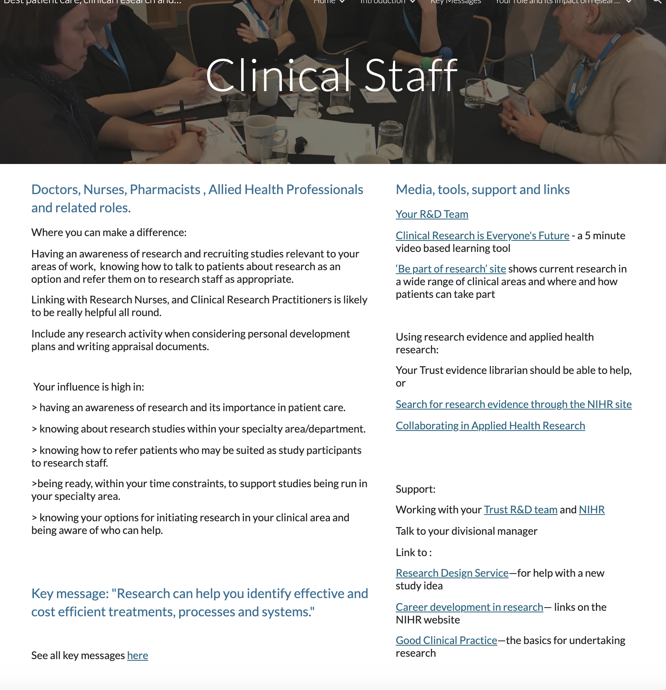

Page ID:
- Clinical Staff

Text content:
- Text, key message and key message link required - (left hand in above)
- Media, tools, support and links - supporting links re Trust R&D team can be localised and any other local resources added

Visual (non text) content and general layout:
- Keep what is in each column above associated in your local layout but do not conflate. Additional local pictures/visuals can be added.

Navigation:
- Back navigation is important

Text for copying:

Title: Doctors, Nurses, Pharmacists , Allied Health Professionals, and related roles.

Where you can make a difference:

Having an awareness of research and recruiting studies relevant to your areas of work, knowing how to talk to patients about research as an option and refer them on to research staff as appropriate.

Linking with Research Nurses, and Clinical Research Practitioners is likely to be really helpful all round.

Include any research activity when considering personal development plans and writing appraisal documents.

Your influence is high in:

> having an awareness of research and its importance in patient care.

> knowing about research studies within your specialty area/department.

> knowing how to refer patients who may be suited as study participants to research staff.

>being ready, within your time constraints, to support studies being run in your specialty area.

> knowing your options for initiating research in your clinical area and being aware of who can help.

Key message: "Research can help you identify effective and cost efficient treatments, processes and systems."

See all key messages here

Media, tools, support and links:

Your R&D Team
Link:Insert link to local R&D Team

Clinical Research is Everyone’s Future- a 5 minute video based learning tool
Link: https://vimeo.com/240168616

‘Be part of research’ site shows current research in a wide range of clinical areas and where and how patients can take part
Link: https://bepartofresearch.nihr.ac.uk/

Subheading: Using research evidence and applied health research

Your Trust evidence librarian should be able to help, or...

Search for research evidence through the NIHR site
Link: https://www.nihr.ac.uk/health-and-care-professionals/search-our-evidence.htm
Collaborating in Applied Health Research
Link: https://www.nihr.ac.uk/explore-nihr/support/collaborating-in-applied-health-research.htm

Subheading: Support

Working with your Trust R&D team and NIHR
Link: Insert link to local R&D team or add guidance link (https://sites.google.com/nihr.ac.uk/bestpatientcareclinicalresearc/home/working-with-nhs-rd)
NIHR
Link: https://sites.google.com/nihr.ac.uk/bestpatientcareclinicalresearc/home/how-the-nihr-can-support-your-research

Subheading: Talk to your divisional manager
Research Design Service—for help with a new study idea
Link: https://www.nihr.ac.uk/explore-nihr/support/research-design-service.htm
Career development in research— links on the NIHR website
Link: https://www.nihr.ac.uk/health-and-care-professionals/career-development/
Good Clinical Practice—the basics for undertaking research
Link: https://www.nihr.ac.uk/health-and-care-professionals/learning-and-support/good-clinical-practice.htm

