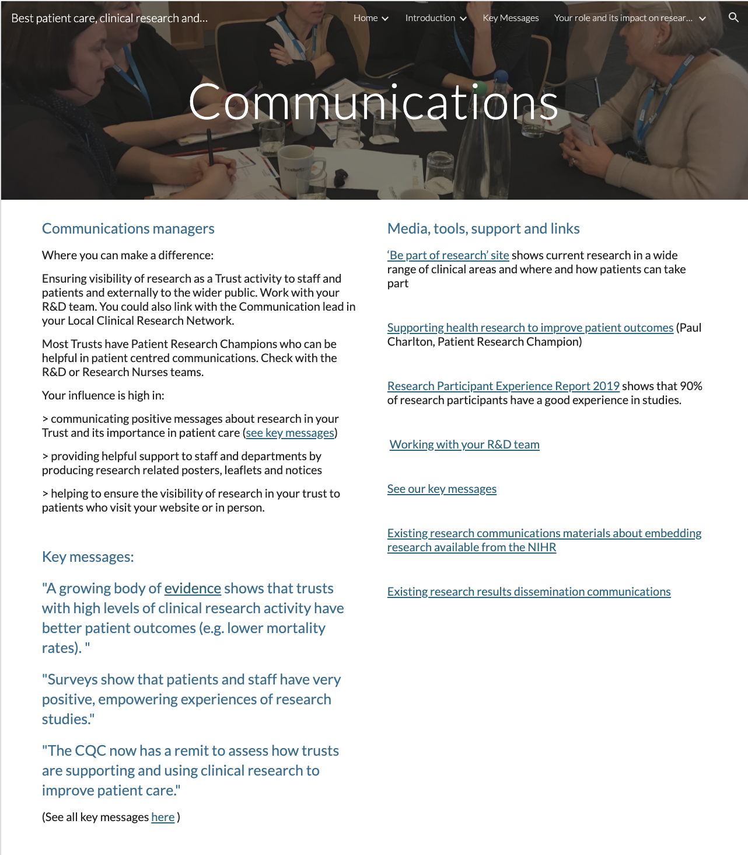

Page ID:
- Communications Managers

Text content:
- Text, key message and key message link required - (left hand in above)
- Media, tools, support and links - supporting links re Trust R&D team can be localised and any other local resources added

Visual (non text) content and general layout:
- Keep what is in each column above associated in your local layout but do not conflate. Additional local pictures/visuals can be added.

Navigation:
- Back navigation is important

Text for copying:

Communications managers

Where you can make a difference:

Ensuring visibility of research as a Trust activity to staff and patients and externally to the wider public. Work with your R&D team. You could also link with the Communication lead in your Local Clinical Research Network.

Most Trusts have Patient Research Champions who can be helpful in patient centred communications. Check with the R&D or Research Nurses teams.

Your influence is high in:

> communicating positive messages about research in your Trust and its importance in patient care (see key messages)

> providing helpful support to staff and departments by producing research related posters, leaflets and notices

> helping to ensure the visibility of research in your trust to patients who visit your website or in person.

Key messages:

"A growing body of evidence shows that trusts with high levels of clinical research activity have better patient outcomes (e.g. lower mortality rates). "

"Surveys show that patients and staff have very positive, empowering experiences of research studies."

"The CQC now has a remit to assess how trusts are supporting and using clinical research to improve patient care."

(See all key messages here )

Media, tools, support and links

‘Be part of research’ site shows current research in a wide range of clinical areas and where and how patients can take part
Link: https://bepartofresearch.nihr.ac.uk/

Supporting health research to improve patient outcomes (Paul Charlton, Patient Research Champion)
Link: https://www.youtube.com/watch?v=6nsUBT3eeWo&list=PLIa1oelW_zJ-6wCIS1ROKJnx4RY360v7q&index=5&t=0s

Research Participant Experience Report 2019 shows that 90% of research participants have a good experience in studies.
Link: https://www.nihr.ac.uk/patients-carers-and-the-public/i-want-to-learn-about-research/participant-in-research-experience-survey.htm

Working with your R&D Team
Link: https://sites.google.com/nihr.ac.uk/bestpatientcareclinicalresearc/home/working-with-nhs-rd

See our key messages
Link: https://sites.google.com/d/10Knt1KSQwyUlNqCuCyHUwCiELBc7NKhU/p/1Ry6-v40UnJ2F6IGqvL9qbcf8HfNV0cOF/edit

Existing research communications materials about embedding research available from the NIHR
Link:https://www.nihr.ac.uk/health-and-care-professionals/engagement-and-participation-in-research/embedding-a-research-culture.htm

Existing research results dissemination communications
Link: https://www.nihr.ac.uk/news/nihr-launches-new-centre-for-engagement-and-dissemination/24576

