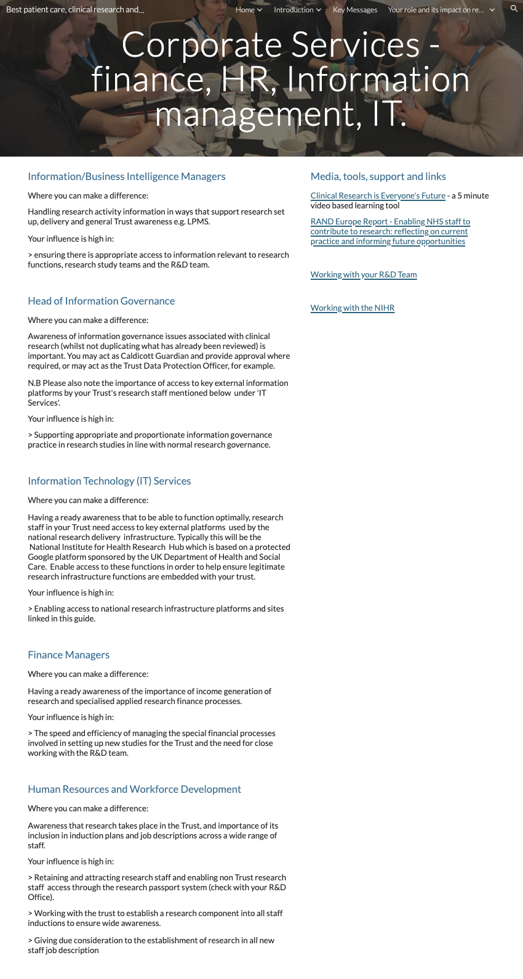
Page ID:
- Corporate Services - HR, Finance, Information management, IT

Text content:
- Text, key message and key message link required - (left hand in above)
- Media, tools, support and links - supporting links re Trust R&D team can be localised and any other local resources added

Visual (non text) content and general layout:
- Keep what is in each column above associated in your local layout but do not conflate. Additional local pictures/visuals can be added.

Navigation:
- Back navigation is important

Text for copying:

Information/Business Intelligence Managers

Where you can make a difference:

Handling research activity information in ways that support research set up, delivery and general Trust awareness e.g. LPMS.

Your influence is high in:

> ensuring there is appropriate access to information relevant to research functions, research study teams and the R&D team.

Head of Information Governance

Where you can make a difference:

Awareness of information governance issues associated with clinical research (whilst not duplicating what has already been reviewed) is important. You may act as Caldicott Guardian and provide approval where required, or may act as the Trust Data Protection Officer, for example.

N.B Please also note the importance of access to key external information platforms by your Trust's research staff mentioned below under 'IT Services'.

Your influence is high in:

> Supporting appropriate and proportionate information governance practice in research studies in line with normal research governance.

Information Technology (IT) Services

Where you can make a difference:

Having a ready awareness that to be able to function optimally, research staff in your Trust need access to key external platforms used by the national research delivery infrastructure. Typically this will be the National Institute for Health Research Hub which is based on a protected Google platform sponsored by the UK Department of Health and Social Care. Enable access to these functions in order to help ensure legitimate research infrastructure functions are embedded with your trust.

Your influence is high in:

> Enabling access to national research infrastructure platforms and sites linked in this guide.

Finance Managers

Where you can make a difference:

Having a ready awareness of the importance of income generation of research and specialised applied research finance processes.

Your influence is high in:

> The speed and efficiency of managing the special financial processes involved in setting up new studies for the Trust and the need for close working with the R&D team.

Human Resources and Workforce Development

Where you can make a difference:

Awareness that research takes place in the Trust, and importance of its inclusion in induction plans and job descriptions across a wide range of staff.

Your influence is high in:

> Retaining and attracting research staff and enabling non Trust research staff access through the research passport system (check with your R&D Office).

> Working with the trust to establish a research component into all staff inductions to ensure wide awareness.

> Giving due consideration to the establishment of research in all new staff job description

Media, tools, support and links

Clinical Research is Everyone's Future - a 5 minute video based learning tool
Link:https://vimeo.com/240168616

RAND Europe Report - Enabling NHS staff to contribute to research: reflecting on current practice and informing future opportunities
Link: https://www.rand.org/randeurope/research/projects/enabling-nhs-staff-to-contribute-to-research.html

Working with your R&D Team
Link:Insert link to local R&D team or add guidance link (https://sites.google.com/nihr.ac.uk/bestpatientcareclinicalresearc/home/working-with-nhs-rd)

Working with the NIHR
Link:https://sites.google.com/nihr.ac.uk/bestpatientcareclinicalresearc/home/how-the-nihr-can-support-your-research

