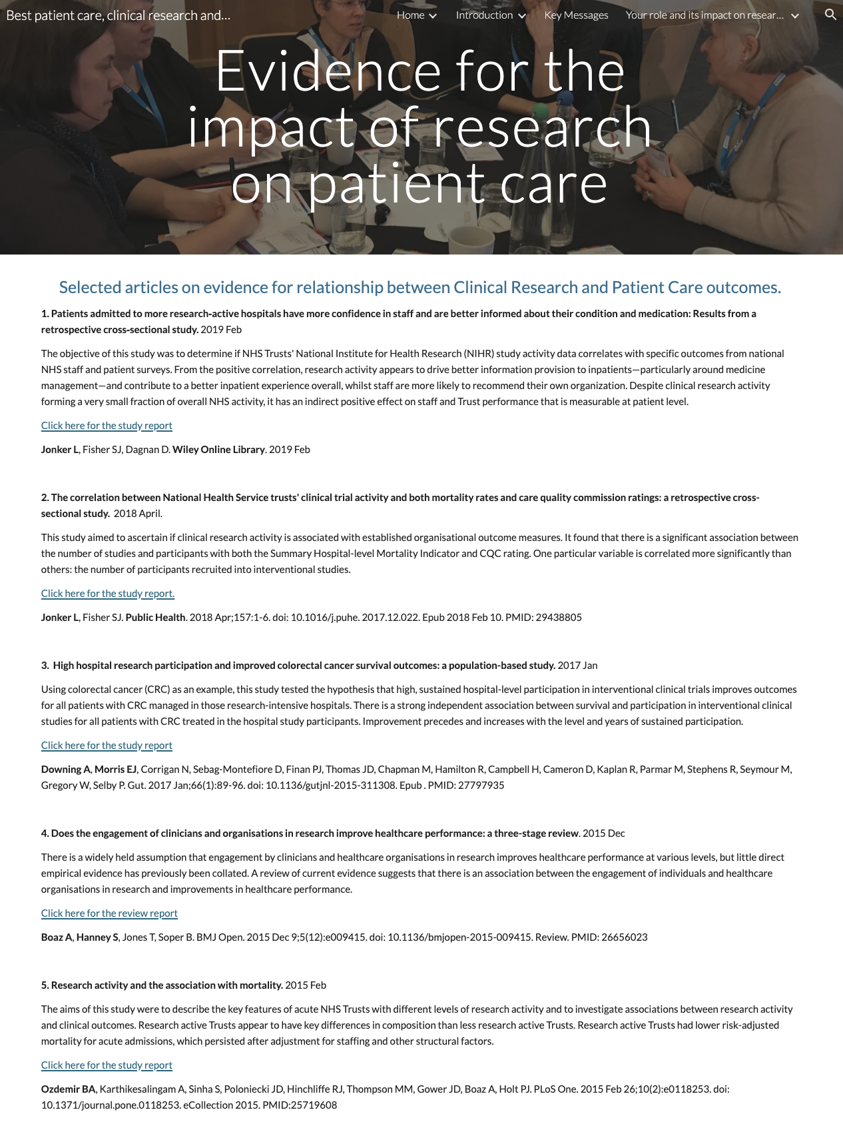

Page ID:
- Evidence for the impact of research on patient care

Text content:
- All content required
- Add any local work relevant to this topic

Visual (non text) content and general layout:
- Basically a list but it could be interspersed with relevant local images

Navigation:
Ensure it is linked to from various relevant pages as per those page guides.

Text for copying:

Selected articles on evidence for relationship between Clinical Research and Patient Care outcomes.
1. Patients admitted to more research‐active hospitals have more confidence in staff and are better informed about their condition and medication: Results from a retrospective cross‐sectional study. 2019 Feb
The objective of this study was to determine if NHS Trusts' National Institute for Health Research (NIHR) study activity data correlates with specific outcomes from national NHS staff and patient surveys. From the positive correlation, research activity appears to drive better information provision to inpatients—particularly around medicine management—and contribute to a better inpatient experience overall, whilst staff are more likely to recommend their own organization. Despite clinical research activity forming a very small fraction of overall NHS activity, it has an indirect positive effect on staff and Trust performance that is measurable at patient level.
Click here for the study report
Jonker L, Fisher SJ, Dagnan D. Wiley Online Library. 2019 Feb

2. The correlation between National Health Service trusts' clinical trial activity and both mortality rates and care quality commission ratings: a retrospective cross-sectional study. 2018 April.
This study aimed to ascertain if clinical research activity is associated with established organisational outcome measures. It found that there is a significant association between the number of studies and participants with both the Summary Hospital-level Mortality Indicator and CQC rating. One particular variable is correlated more significantly than others: the number of participants recruited into interventional studies.
Click here for the study report.
Jonker L, Fisher SJ. Public Health. 2018 Apr;157:1-6. doi: 10.1016/j.puhe. 2017.12.022. Epub 2018 Feb 10. PMID: 29438805

3. High hospital research participation and improved colorectal cancer survival outcomes: a population-based study. 2017 Jan
Using colorectal cancer (CRC) as an example, this study tested the hypothesis that high, sustained hospital-level participation in interventional clinical trials improves outcomes for all patients with CRC managed in those research-intensive hospitals. There is a strong independent association between survival and participation in interventional clinical studies for all patients with CRC treated in the hospital study participants. Improvement precedes and increases with the level and years of sustained participation.
Click here for the study report
Downing A, Morris EJ, Corrigan N, Sebag-Montefiore D, Finan PJ, Thomas JD, Chapman M, Hamilton R, Campbell H, Cameron D, Kaplan R, Parmar M, Stephens R, Seymour M, Gregory W, Selby P. Gut. 2017 Jan;66(1):89-96. doi: 10.1136/gutjnl-2015-311308. Epub . PMID: 27797935

4. Does the engagement of clinicians and organisations in research improve healthcare performance: a three-stage review. 2015 Dec
There is a widely held assumption that engagement by clinicians and healthcare organisations in research improves healthcare performance at various levels, but little direct empirical evidence has previously been collated. A review of current evidence suggests that there is an association between the engagement of individuals and healthcare organisations in research and improvements in healthcare performance.
Click here for the review report
Boaz A, Hanney S, Jones T, Soper B. BMJ Open. 2015 Dec 9;5(12):e009415. doi: 10.1136/bmjopen-2015-009415. Review. PMID: 26656023

5. Research activity and the association with mortality. 2015 Feb
The aims of this study were to describe the key features of acute NHS Trusts with different levels of research activity and to investigate associations between research activity and clinical outcomes. Research active Trusts appear to have key differences in composition than less research active Trusts. Research active Trusts had lower risk-adjusted mortality for acute admissions, which persisted after adjustment for staffing and other structural factors.
Click here for the study report
Ozdemir BA, Karthikesalingam A, Sinha S, Poloniecki JD, Hinchliffe RJ, Thompson MM, Gower JD, Boaz A, Holt PJ. PLoS One. 2015 Feb 26;10(2):e0118253. doi: 10.1371/journal.pone.0118253. eCollection 2015. PMID:25719608

