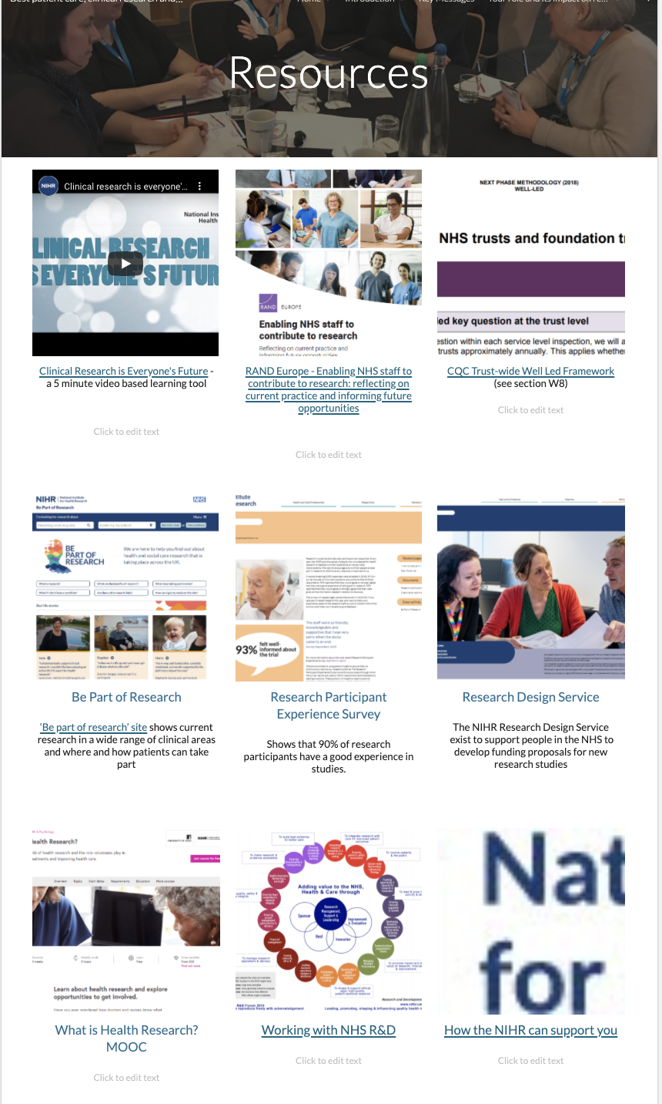
Page ID:
- General Resources

Text content:
Maintain the national resource tiles/links and be mindful that these will occasionally be added to or updated.

Visual (non text) content and general layout:
- Pictorial Tiles are recommended

Navigation:
- Back navigation is important

Links to resources:

Clinical Research is Everyone’s Future: What is Clinical Research?
Link: https://vimeo.com/240168616

RAND Europe - Enabling NHS staff to contribute to research: reflecting on current practice and informing future opportunities
Link: https://www.rand.org/randeurope/research/projects/enabling-nhs-staff-to-contribute-to-research.html

CQC Trust-wide Well Led Framework
Link: https://www.cqc.org.uk/sites/default/files/20200115_Trust_wide_well_led_inspection_framework_V7.pdf

Be Part of Research
Link: https://www.cqc.org.uk/sites/default/files/20200115_Trust_wide_well_led_inspection_framework_V7.pdf

Research Participant Experience Survey
Link: https://www.nihr.ac.uk/patients-carers-and-the-public/i-want-to-learn-about-research/participant-in-research-experience-survey.htm

Research Design Service
Link: https://www.nihr.ac.uk/explore-nihr/support/research-design-service.htm

What is Health Research?
Link: https://www.futurelearn.com/courses/what-is-health-research

Working with NHS R&D
Link: https://sites.google.com/d/10Knt1KSQwyUlNqCuCyHUwCiELBc7NKhU/p/1QlNcxrkjvFz1J7miqNBaGoxYHLUEvdww/edit

How the NIHR can support your research
Link: https://sites.google.com/d/10Knt1KSQwyUlNqCuCyHUwCiELBc7NKhU/p/1LSS5YPsGo8NP34TbuSrFizT6Tc2rsipQ/edit

