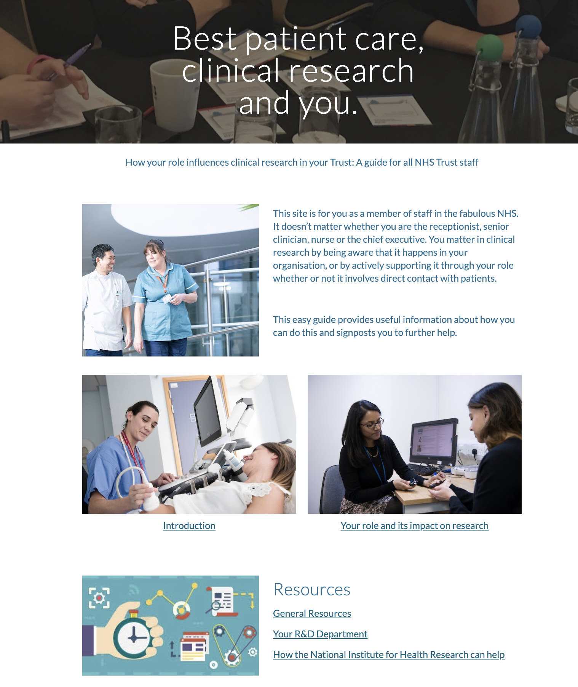

Page ID:
- Home page

Corporatisation and badging:
- local styles and badge
- Add partnership badging - NIHR, NHSE, UKRD, NHS R&D

Text content:
- All text required.
- Some localisation can be added/edited in

Pictures, diagrams content and general layout:
- Can be localised

Navigation:
- Basic navigation to ‘Introduction’ page and ‘Staff roles’ required
- Resource pages navigation section recommended

Text for copying:

Title: Best Patient Care, Clinical Research, and You

Subtitle: How your role influences clinical research in your Trust: A guide for all NHS Trust staff

Body: This site is for you as a member of staff in the fabulous NHS. It doesn’t matter whether you are the receptionist, senior clinician, nurse or the chief executive. You matter in clinical research by being aware that it happens in your organisation, or by actively supporting it through your role whether or not it involves direct contact with patients.

This easy guide provides useful information about how you can do this and signposts you to further help.

Internal links to be included:

Introduction
Link: https://sites.google.com/nihr.ac.uk/bestpatientcareclinicalresearc/introduction

Your role and its impact on clinical research
Link: https://sites.google.com/nihr.ac.uk/bestpatientcareclinicalresearc/your-role-and-its-impact-on-research

General Resources
Link: https://sites.google.com/nihr.ac.uk/bestpatientcareclinicalresearc/home/resources

Your R&D Department
Link: https://sites.google.com/nihr.ac.uk/bestpatientcareclinicalresearc/home/working-with-nhs-rd

How the National Institute for Health Research can help
Link: https://sites.google.com/nihr.ac.uk/bestpatientcareclinicalresearc/home/how-the-nihr-can-support-your-research

