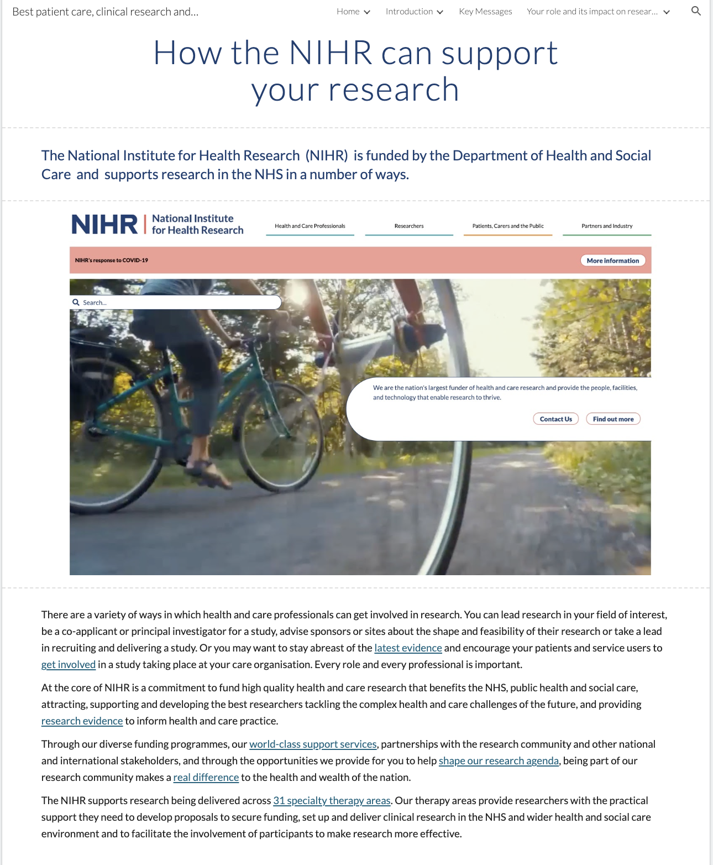

Page ID:
- How the NIHR can support your research

Text content:
Text content here is from the national NIHR Website and is suggested. It is recommended that the text is principally guided by your local/regional NIHR organisations, for example Local Clinical Research Network (LCRN), Research Design Service (RDS), and Applied Research Collaboration (ARC).

Visual (non text) content and general layout:
- Juxtapose text with relevant local photographs and diagrams

Navigation:
- Links to the NIHR website to be included with links to local NIHR teams. Back navigation is important

Links embedded within the text:

Latest evidence
Link: https://www.nihr.ac.uk/health-and-care-professionals/search-our-evidence.htm

Get involved
Link: https://www.nihr.ac.uk/health-and-care-professionals/engagement-and-participation-in-research/involve-patients.htm

Support to develop your career
Link: https://www.nihr.ac.uk/health-and-care-professionals/career-development/

Learning and support
Link: https://www.nihr.ac.uk/health-and-care-professionals/learning-and-support/

Engagement and participation in research
Link: https://www.nihr.ac.uk/health-and-care-professionals/engagement-and-participation-in-research/

Specialty therapy areas
Link: https://www.nihr.ac.uk/explore-nihr/specialties/

Research evidence
Link: https://www.nihr.ac.uk/researchers/search-our-evidence.htm

World-class support services
Link: https://www.nihr.ac.uk/researchers/collaborations-services-and-support-for-your-research/

Shape our research agenda
Link: https://www.nihr.ac.uk/researchers/influence-our-research.htm

Making a difference
Link: https://www.nihr.ac.uk/about-us/making-a-difference/

Apply for funding
Link: https://www.nihr.ac.uk/researchers/apply-for-funding/

Manage your funding
Link: https://www.nihr.ac.uk/researchers/manage-your-funding/

How to apply for career development support
Link: https://www.nihr.ac.uk/researchers/apply-for-funding/how-to-apply-for-career-development-support/how-to-apply-for-career-development-support

Networking events / Involvement opportunities
Link: https://www.nihr.ac.uk/researchers/apply-for-funding/how-to-apply-for-career-development-support/involvement-opportunities

