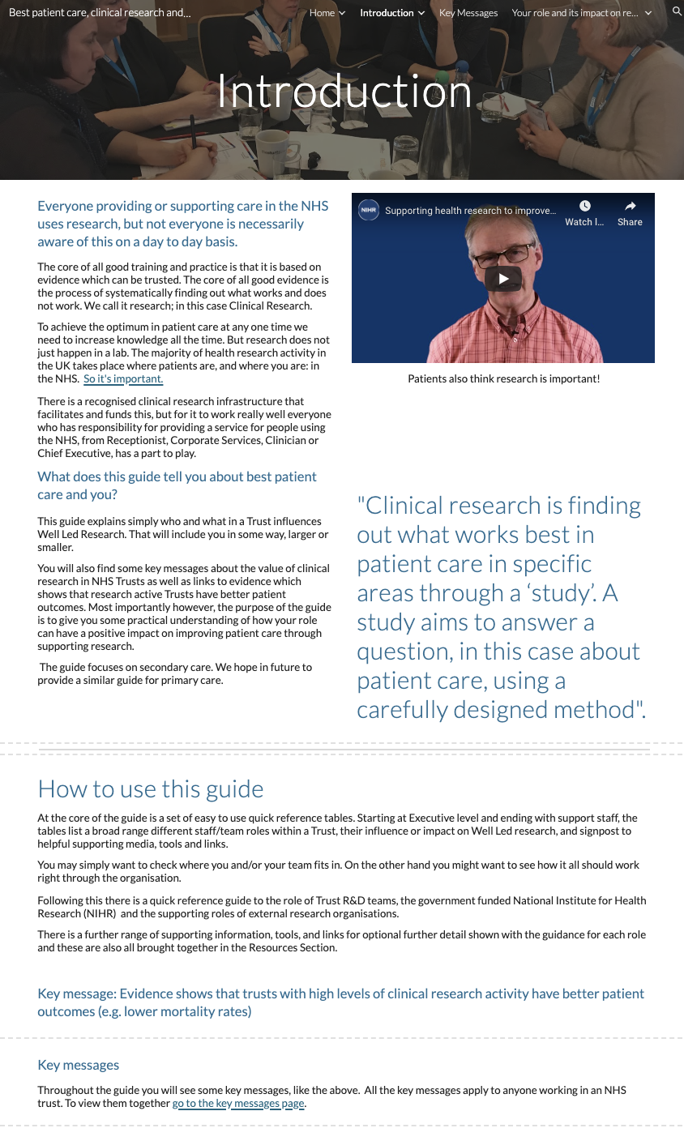
Page ID:
- Introduction page

Corporatisation and badging:
- local styles and badge

Text content:
- All text required in the first section.
- Some localisation can be added/edited in
- In how to use this guide, content can be localised to suit local styles

Visual (non text) content and general layout:
- Can be localised
- Video required

Navigation:
Links to ‘Why Research is Important’ Page and ‘Key Messages’ Page required as per screenshot above.

Text for copying:

Title: Introduction

Section 1: Everyone providing or supporting care in the NHS uses research, but not everyone is necessarily aware of this on a day to day basis.

Everyone providing or supporting care in the NHS uses research, but not everyone is necessarily aware of this on a day to day basis.

The core of all good training and practice is that it is based on evidence which can be trusted. The core of all good evidence is the process of systematically finding out what works and does not work. We call it research; in this case Clinical Research.

To achieve the optimum in patient care at any one time we need to increase knowledge all the time. But research does not just happen in a lab. The majority of health research activity in the UK takes place where patients are, and where you are: in the NHS. So it's important.

There is a recognised clinical research infrastructure that facilitates and funds this, but for it to work really well everyone who has responsibility for providing a service for people using the NHS, from Receptionist, Corporate Services, Clinician or Chief Executive, has a part to play.

What does this guide tell you about best patient care and you?

This guide explains simply who and what in a Trust influences Well Led Research. That will include you in some way, larger or smaller.

You will also find some key messages about the value of clinical research in NHS Trusts as well as links to evidence which shows that research active Trusts have better patient outcomes. Most importantly however, the purpose of the guide is to give you some practical understanding of how your role can have a positive impact on improving patient care through supporting research.

The guide focuses on secondary care. We hope in future to provide a similar guide for primary care.

Section 2: How to use this guide

At the core of the guide is a set of easy to use quick reference pages. Starting at Executive level and ending with support staff, the tables list a broad range of different staff/team roles within a Trust, their influence or impact on Well Led research, and signpost to helpful supporting media, tools and links.

You may simply want to check where you and/or your team fits in. On the other hand you might want to see how it all should work right through the organisation.

Following this there is a quick reference guide to the role of Trust R&D teams, the government funded National Institute for Health Research (NIHR) and the supporting roles of external research organisations.

There is a further range of supporting information, tools, and links for optional further detail shown with the guidance for each role and these are also all brought together in the Resources Section.

Key message: Evidence shows that trusts with high levels of clinical research activity have better patient outcomes (e.g. lower mortality rates)

Key messages

Throughout the guide you will see some key messages, like the above. All the key messages apply to anyone working in an NHS trust. To view them together go to the key messages page.

