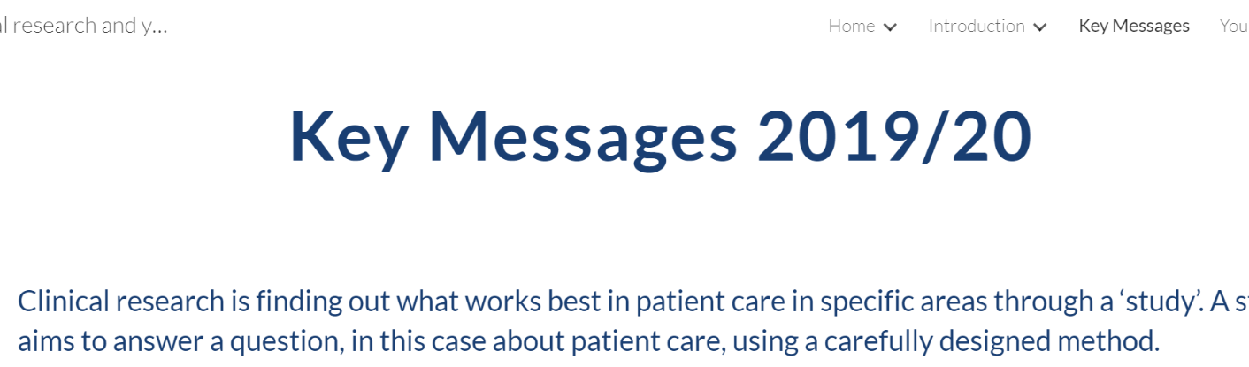

Page ID:

- Key Messages

Guidance:

The below messaging should be clear throughout the guide.You don’t necessarily need a page dedicated to this if you don’t wish to, we encourage you to use each message as you see fit:

- Clinical research is finding out what works best in patient care in specific areas through a ‘study’. A study aims to answer a question, in this case about patient care, using a carefully designed method.
- Everyone providing care in the NHS uses research. But not everyone is aware of it. The core of all good training is that it is based on evidence which can be trusted.
- A growing body of evidence shows that trusts with high levels of clinical research activity have better patient outcomes (e.g. lower mortality rates).
- The CQC now has a remit to assess how trusts are supporting and using clinical research to improve patient care.
- Research can help you identify effective and cost efficient treatments, processes and systems.
- Surveys show that patients and staff have very positive, empowering experiences of research studies.

