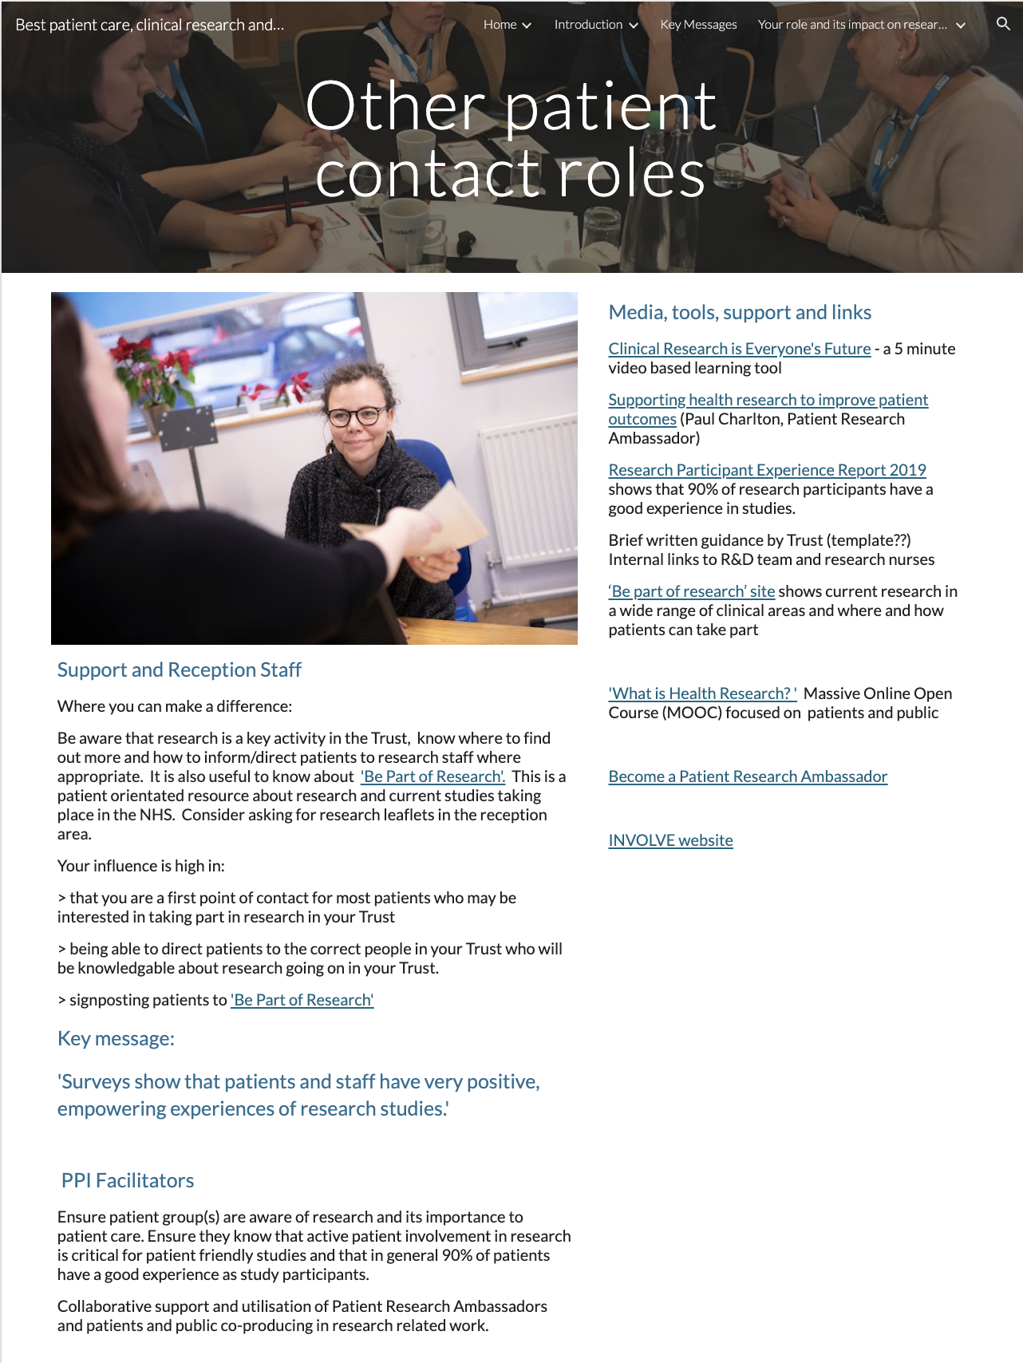

Page ID:
- Other patient contact roles

Text content:
- Text, key message and key message link required - (left hand in above)
- Media, tools, support and links - supporting links re Trust R&D team can be localised and any other local resources added

Visual (non text) content and general layout:
- Keep what is in each column above associated in your local layout but do not conflate. Additional local pictures/visuals can be added.

Navigation:
- Back navigation is important

Text for copying:

Support and Reception Staff

Where you can make a difference:

Be aware that research is a key activity in the Trust, know where to find out more and how to inform/direct patients to research staff where appropriate. It is also useful to know about 'Be Part of Research'. This is a patient orientated resource about research and current studies taking place in the NHS. Consider asking for research leaflets in the reception area.

Your influence is high in:

> that you are a first point of contact for most patients who may be interested in taking part in research in your Trust

> being able to direct patients to the correct people in your Trust who will be knowledgable about research going on in your Trust.

> signposting patients to 'Be Part of Research'

Key message:

'Surveys show that patients and staff have very positive, empowering experiences of research studies.'

Patient and Public Involvement Facilitators

Ensure patient group(s) are aware of research and its importance to patient care. Ensure they know that active patient involvement in research is critical for patient friendly studies and that in general 90% of patients have a good experience as study participants.

Collaborative support and utilisation of Public Research Champions and patients and public co-producing in research related work.

Media, tools, support and links

Clinical Research is Everyone's Future - a 5 minute video based learning tool
Link: https://vimeo.com/240168616

Supporting health research to improve patient outcomes (Paul Charlton, Patient Research Ambassador)
Link: https://www.youtube.com/watch?v=6nsUBT3eeWo&list=PLIa1oelW_zJ-6wCIS1ROKJnx4RY360v7q&index=5&t=0s

Research Participant Experience Report 2019 shows that 90% of research participants have a good experience in studies.
Link:https://www.nihr.ac.uk/patients-carers-and-the-public/i-want-to-learn-about-research/participant-in-research-experience-survey.htm

Brief written guidance by Trust (template??) Internal links to R&D team and research nurses
Link: Insert link to R&D Team and research nurses internal webpage.

‘Be part of research’ site shows current research in a wide range of clinical areas and where and how patients can take part
Link: https://bepartofresearch.nihr.ac.uk/

'What is Health Research? ' Massive Online Open Course (MOOC) focused on patients and public
Link: https://www.futurelearn.com/courses/what-is-health-research

Become a Research Champion
Link: https://www.nihr.ac.uk/patients-carers-and-the-public/i-want-to-help-with-research/research-champions.htm

INVOLVE website
Link: https://www.invo.org.uk/

