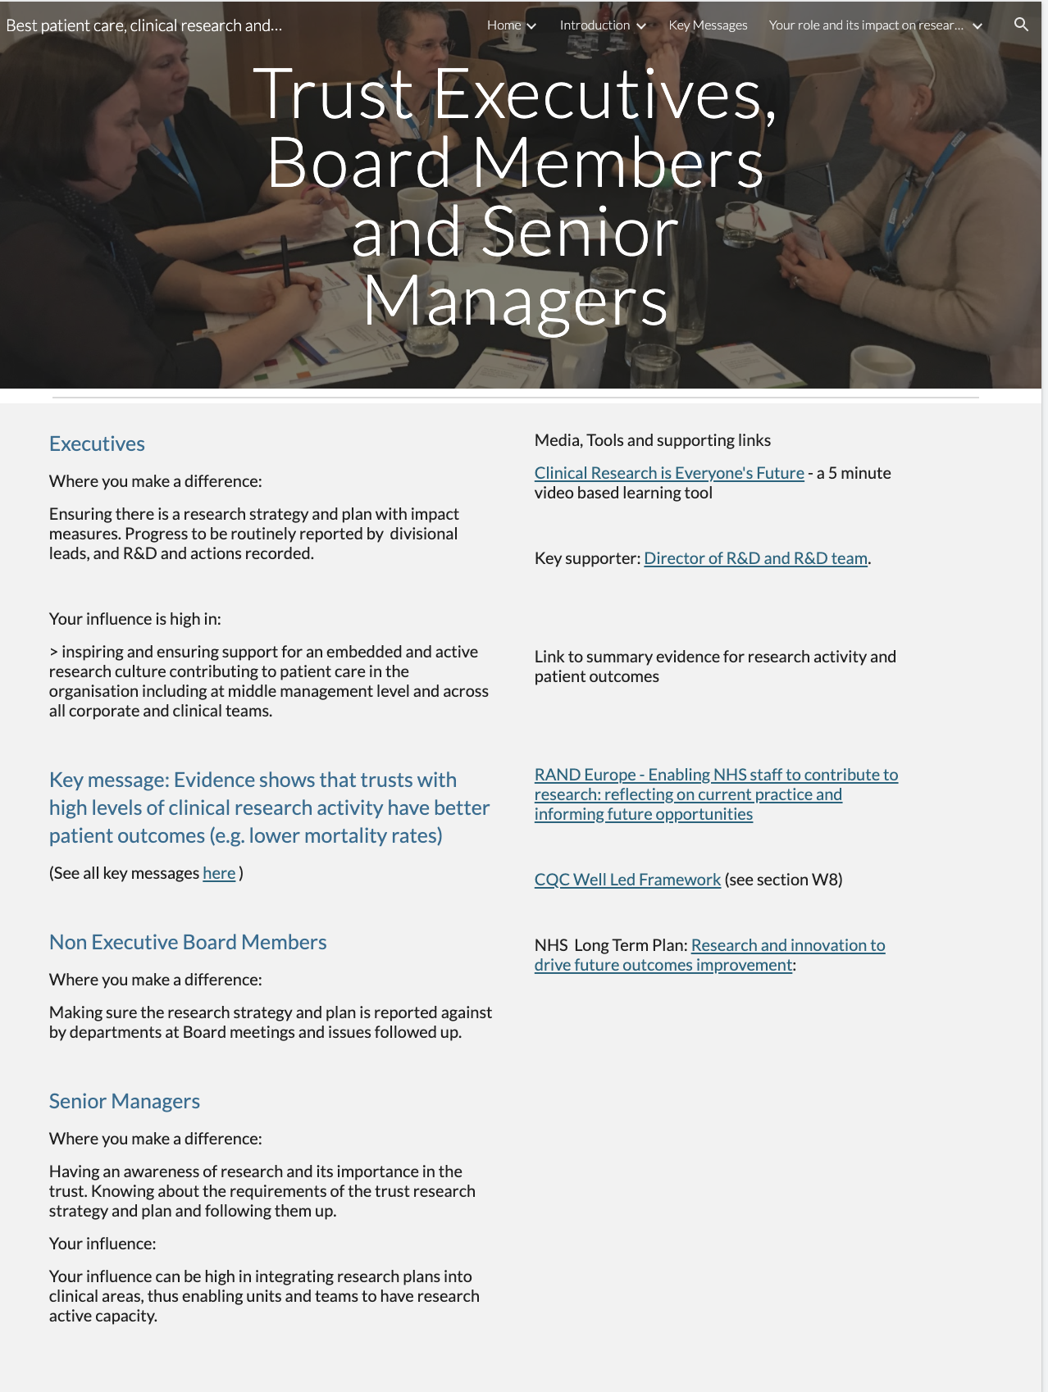
<<<UPDATE FROM MOCKUP TO INCLUDE CHAIRS>>>

Page ID:
- Trust Executives, Board Members and Senior Managers

Text content:
- Text, key message and key message link required - (left hand in above)
- Media, tools, support and links - supporting links re Trust R&D team can be localised and any other local resources added

Visual (non text) content and general layout:
- Keep what is in each column above associated in your local layout but do not conflate. Additional local pictures/visuals can be added.

Navigation:
- Back navigation is important

Text for copying:

Trust Chair

Where you make a difference:
Setting the tone for the organisation that clinical research is integral to best patient care.

Your influence is high in:
> Ensuring that clinical research activity is reported to the board alongside other clinical performance measures.
> Raising awareness with leaders that evidence shows there is a correlation between level of research activity in Trusts and overall patient outcomes.

Executives

Where you make a difference:

Ensuring there is a research strategy and plan with impact measures. Progress to be routinely reported by divisional leads, and R&D and actions recorded.

Your influence is high in:

inspiring and ensuring support for an embedded and active research culture contributing to patient care in the organisation including at middle management level and across all corporate and clinical teams.

Key message: Evidence shows that trusts with high levels of clinical research activity have better patient outcomes (e.g. lower mortality rates)

(See all key messages here )

Non Executive Board Members

Where you make a difference:

Making sure the research strategy and plan is reported against by departments at Board meetings and issues followed up.
Your influence is high in:
> Highlighting the need for building a strong clinical research culture in your Trust
> Ensuring systems for reporting research activity and impact are followed through.

Senior Managers

Where you make a difference:

Having an awareness of research and its importance in the trust. Knowing about the requirements of the trust research strategy and plan and following them up.

Your influence:

Your influence can be high in integrating research plans into clinical areas, thus enabling units and teams to have research active capacity.

Media, Tools and supporting links

Clinical Research is Everyone's Future - a 5 minute video based learning tool
Link:https://vimeo.com/240168616

Evidence for the impact of research on patient care
Link:https://sites.google.com/nihr.ac.uk/bestpatientcareclinicalresearc/introduction/why-research-is-important/evidence-for-the-impact-of-research-on-patient-care

Key supporter: Director of R&D and R&D team.
Link:https://sites.google.com/nihr.ac.uk/bestpatientcareclinicalresearc/home/working-with-nhs-rd

Link to summary evidence for research activity and patient outcomes
Link:

RAND Europe - Enabling NHS staff to contribute to research: reflecting on current practice and informing future opportunities
Link:https://www.rand.org/randeurope/research/projects/enabling-nhs-staff-to-contribute-to-research.html

CQC Well Led Framework (see section W8)
Link: https://www.cqc.org.uk/sites/default/files/20200115_Trust_wide_well_led_inspection_framework_V7.pdf

NHS Long Term Plan: Research and innovation to drive future outcomes improvement:
Link:https://www.longtermplan.nhs.uk/online-version/chapter-3-further-progress-on-care-quality-and-outcomes/better-care-for-major-health-conditions/research-and-innovation-to-drive-future-outcomes-improvement/

