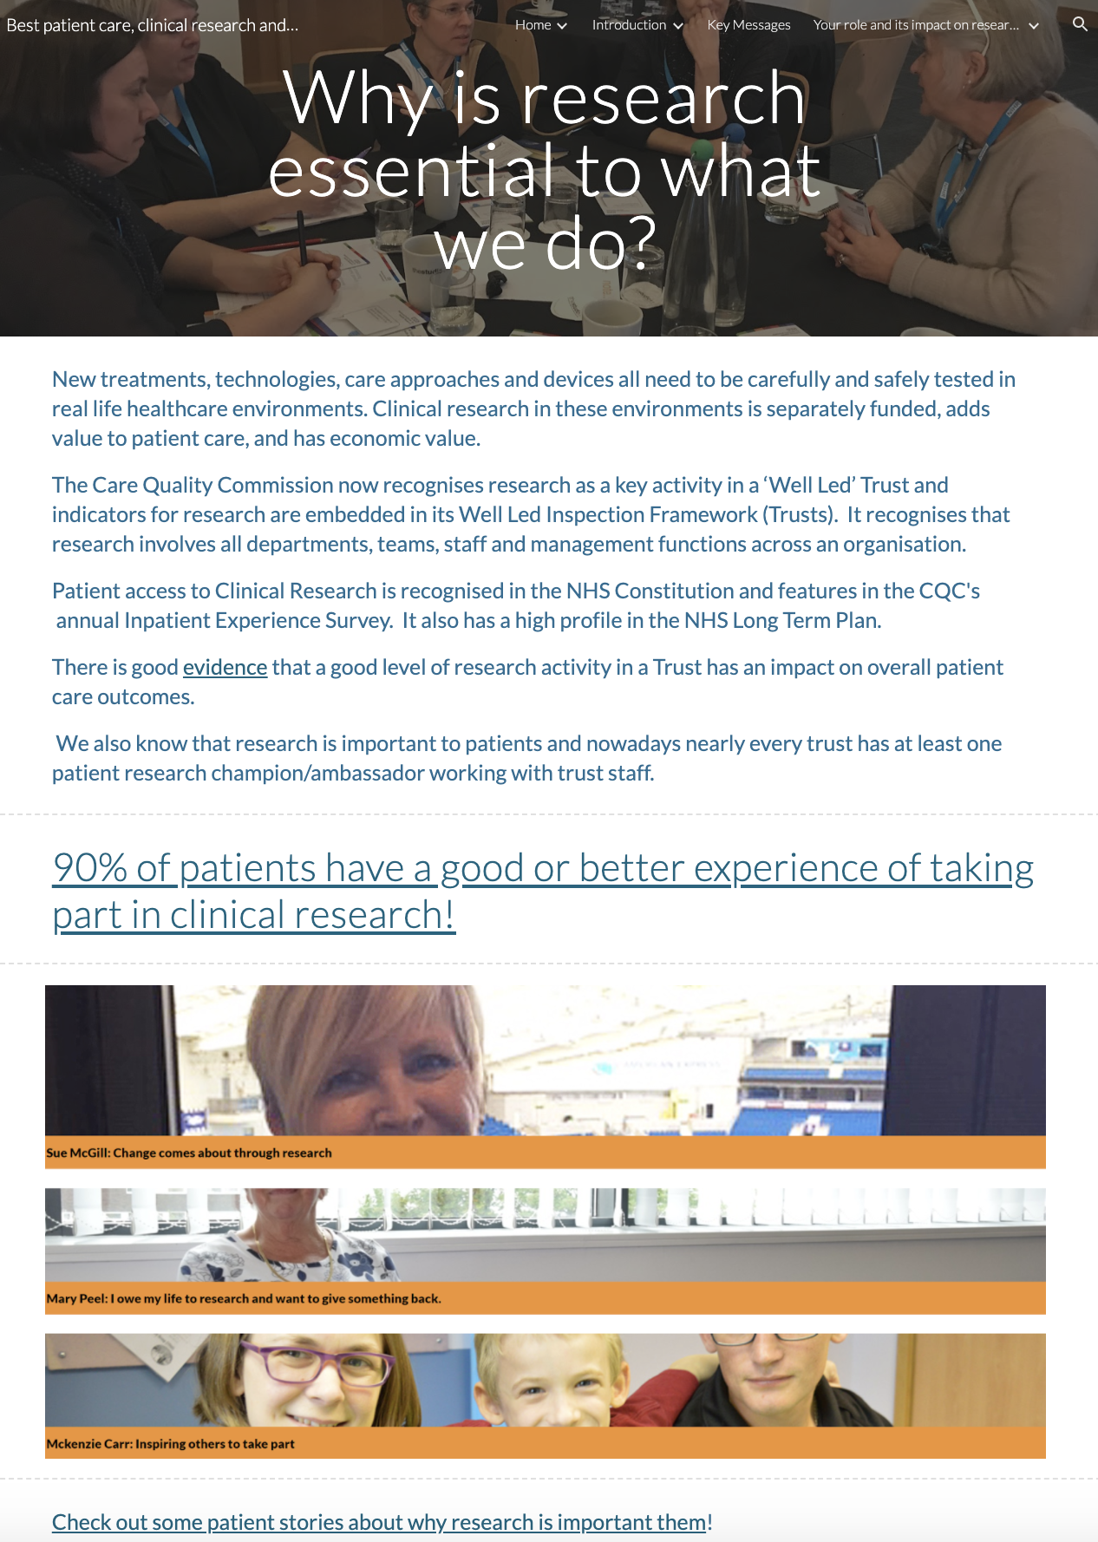

Link to NIHR website’s real life stories

Page ID:
- Why is research important to what we do?

Text content:
- All text required.
- A small selection of your own Trust’s examples or case studies could be added if appropriate.
- Some local copy/links can be added if they are entirely relevant

Visual (non text) content and general layout
- Live linked visuals required
- Additional local photos can be added to give a more local feel

Navigation:
Back navigation to the Introduction page is important

Text for copying:

New treatments, technologies, care approaches and devices all need to be carefully and safely tested in real life healthcare environments. Clinical research in these environments is separately funded, adds value to patient care, and has economic value.

The Care Quality Commission now recognises research as a key activity in a ‘Well Led’ Trust and indicators for research are embedded in its Well Led Inspection Framework (Trusts). It recognises that research involves all departments, teams, staff and management functions across an organisation.

Patient access to Clinical Research is recognised in the NHS Constitution and features in the CQC's annual Inpatient Experience Survey. It also has a high profile in the NHS Long Term Plan.

There is good evidence that a good level of research activity in a Trust has an impact on overall patient care outcomes.

We also know that research is important to patients and nowadays nearly every trust has at least one patient research champion/ambassador working with trust staff.

Check out some patient stories about why research is important them!

