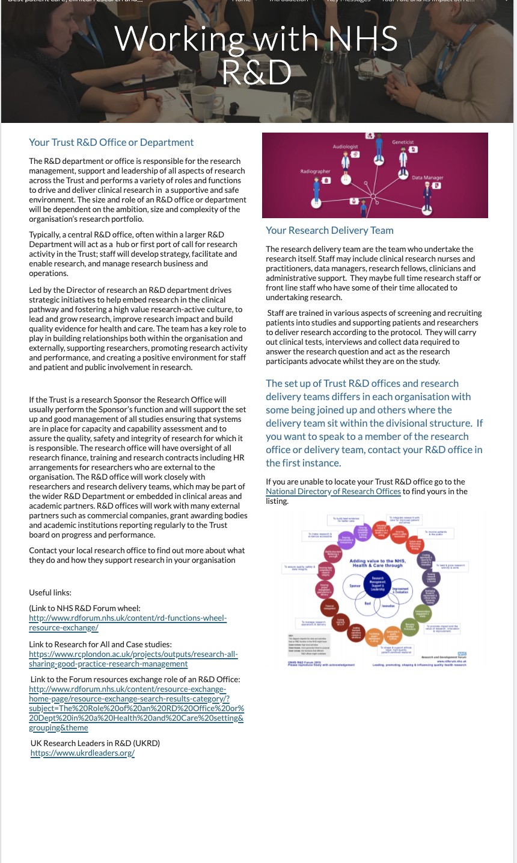
Page ID:
- Working with NHS R&D

Text content:
Text content here gives a broad picture of NHS R&D and is optional. It is recommended that the content here is localised as an introduction to your Trust R&D team whilst an online link to the national R&D Forum site is maintained.

Visual (non text) content and general layout:
- Juxtapose text with relevant local photographs and diagrams

Navigation:
- Links to R&D Forum are to be maintained. Contact links with the local R&D Office required. Back navigation is important

Text for copying:

Your Trust R&D Office or Department

The R&D department or office is responsible for the research management, support and leadership of all aspects of research across the Trust and performs a variety of roles and functions to drive and deliver clinical research in a supportive and safe environment. The size and role of an R&D office or department will be dependent on the ambition, size and complexity of the organisation’s research portfolio.

Typically, a central R&D office, often within a larger R&D Department will act as a hub or first port of call for research activity in the Trust; staff will develop strategy, facilitate and enable research, and manage research business and operations.

Led by the Director of research an R&D department drives strategic initiatives to help embed research in the clinical pathway and fostering a high value research-active culture, to lead and grow research, improve research impact and build quality evidence for health and care. The team has a key role to play in building relationships both within the organisation and externally, supporting researchers, promoting research activity and performance, and creating a positive environment for staff and patient and public involvement in research.

If the Trust is a research Sponsor the Research Office will usually perform the Sponsor’s function and will support the set up and good management of all studies ensuring that systems are in place for capacity and capability assessment and to assure the quality, safety and integrity of research for which it is responsible. The research office will have oversight of all research finance, training and research contracts including HR arrangements for researchers who are external to the organisation. The R&D office will work closely with researchers and research delivery teams, which may be part of the wider R&D Department or embedded in clinical areas and academic partners. R&D offices will work with many external partners such as commercial companies, grant awarding bodies and academic institutions reporting regularly to the Trust board on progress and performance.

Contact your local research office to find out more about what they do and how they support research in your organisation

Useful links:

(Link to NHS R&D Forum wheel: http://www.rdforum.nhs.uk/content/rd-functions-wheel-resource-exchange/

Link to Research for All and Case studies: https://www.rcplondon.ac.uk/projects/outputs/research-all-sharing-good-practice-research-management

Link to the Forum resources exchange role of an R&D Office: http://www.rdforum.nhs.uk/content/resource-exchange-home-page/resource-exchange-search-results-category/?subject=The%20Role%20of%20an%20RD%20Office%20or%20Dept%20in%20a%20Health%20and%20Care%20setting&grouping&theme

UK Research Leaders in R&D (UKRD) https://www.ukrdleaders.org/

Your Research Delivery Team

The research delivery team are the team who undertake the research itself. Staff may include clinical research nurses and practitioners, data managers, research fellows, clinicians and administrative support. They maybe full time research staff or front line staff who have some of their time allocated to undertaking research.

Staff are trained in various aspects of screening and recruiting patients into studies and supporting patients and researchers to deliver research according to the protocol. They will carry out clinical tests, interviews and collect data required to answer the research question and act as the research participants advocate whilst they are on the study.

